ICT PROJECT II – ASSESSMENT TASK

CYCLE REPORT



**SUBMITTED TO:** **SUBMITTED BY:**

LAURA ANTOCHI MANINDER SIAN (13231738)

JAGDEEP KAUR (13129728)

POONAM (13195022)

VENDELL FURTADO (13238166)

Contents

1. Team Description: 3

1.1. Individual contributions to this assessment: 3

2. Delivered Beta release 6

2.1. User stories 6

2.1.1. Home page 6

2.1.2. Picture Gallery 7

2.1.3. Menu 7

2.1.4. Reservations 8

2.1.5. Order now 8

2.2. USER Stories for final release 8

2.2.1. Changing the menu further 9

2.2.2. Customer Feedback 9

2.2.3. Registration/ Log in 9

2.2.4. Adding two more options in the navigation panel. 9

2.2.5. Online search 10

2.2.6. Final Bug fixes 10

3. Burn-down /Velocity chart 10

4. Client signed acceptance of BETA release 12

5. Project development and release ICT infrastructure 12

5.1. Configuration management – Jira Software 12

5.2. Programming languages 13

5.3. Development tools – Android Studio 14

5.4. Testing Tools 16

6. Prototypes for the final release 17

7. References 18

# **Team Description:**

We are making restaurant app of Glory of India. We completed some of our user stories in alpha release but client wanted some changes to made, so we worked on that along with the beta release user stories.

## **Individual contributions to this assessment:**

Maninder Sian (13231738)

* Have made changes in the Menu option by identifying the sub menu option.

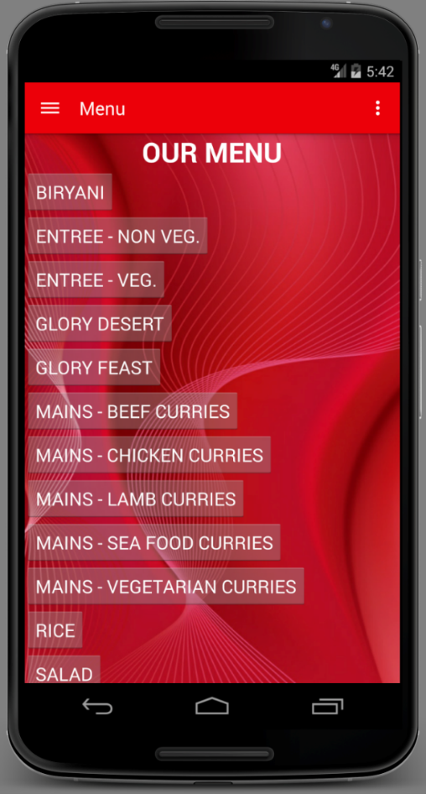 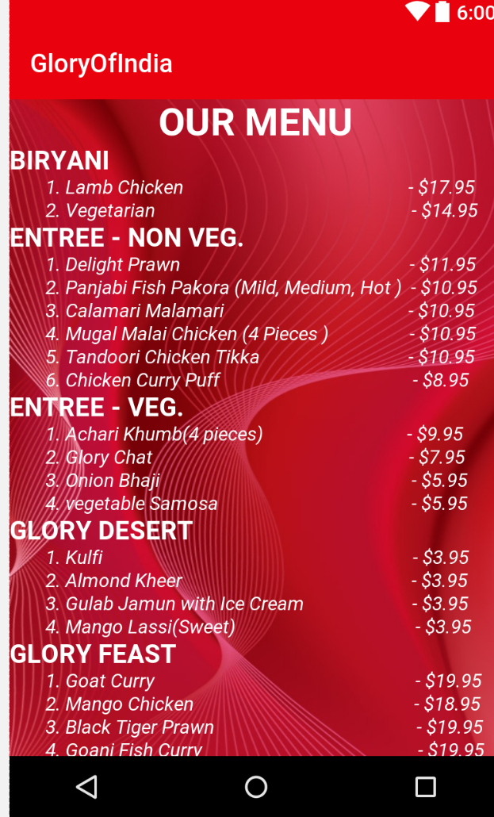

* Compared the beta release results with alpha release.
* Completed the user stories part and helped others in their tasks.

Jagdeep Kaur (13129728)

* Connected Reservation page with Menu Log

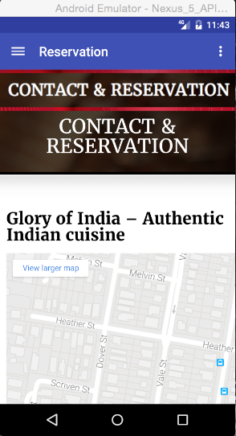 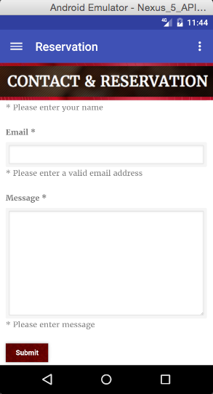

* Burndown chart and helped others in their tasks.

Poonam (13195022)

* Made changes in the Gallery

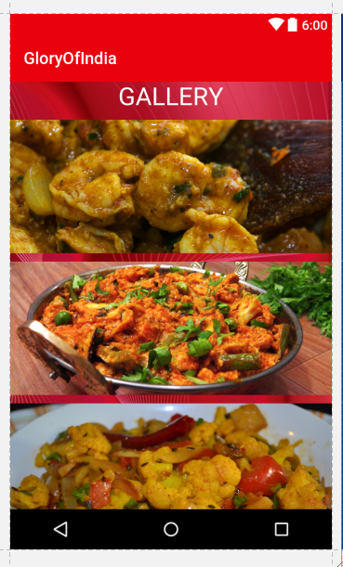 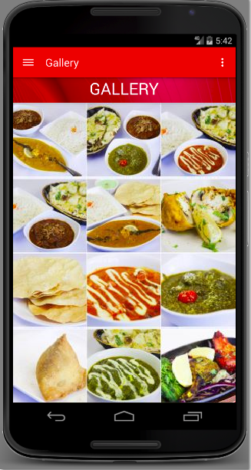

* Calculated Velocity, client signature and helped others in their tasks.

Vendell Furtado (13238166)

* Connected the app with menu log database.

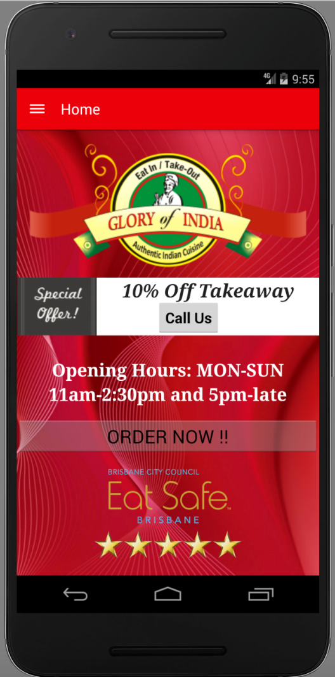 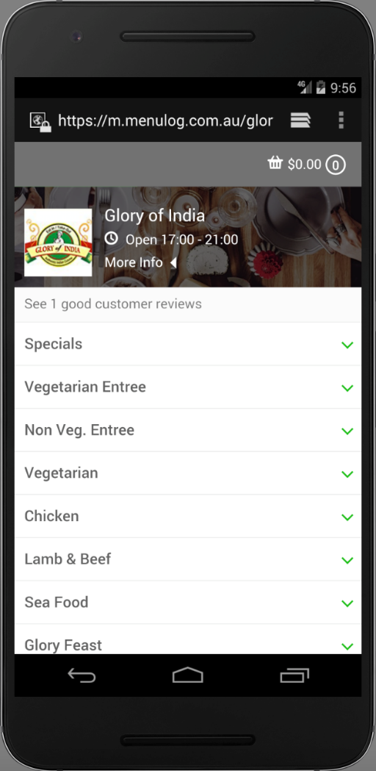

* Defined programming languages used in the app development and helped others in their tasks.

# Delivered Beta release

After alpha release, we have concentrated on delivering the changes as required by the client. We have connected

There are a total 14 user stories including bug fixes for the entire project. But we have presented six user stories with high priority. With agile methodology the following six user stories have been completed along with their demonstration of actual delivered alpha release.

## **User stories**

### **Home page**

Description – The below is the description of the home page in alpha release and the changes made in beta release. The order now link directs the app to the menu log, so that customer can order. The website of the restaurant doesn’t have their own database. It is connected to the menu log, so we have connected it to the menu log. The client doesn’t want to handle separate database.

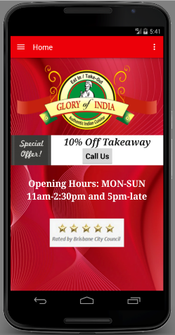 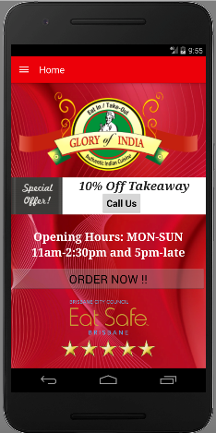

### **Picture Gallery**

Description – It was vertically presented in the alpha release, but in this release, it is changed to grid view as discussed in the last release.

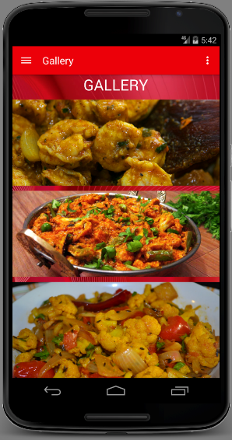 

### **Menu**

Description – There are many changes made in this part of the app. Firstly, we thought to have sub menu option by including number of pages for the menu list. However, after trying for two menu lists/buttons, it became frustrating to click again and again to view the whole menu. We analysed that customer would not prefer to have that many number of clicks to view the menu. So, we changed the plan and made it easier for them to read.

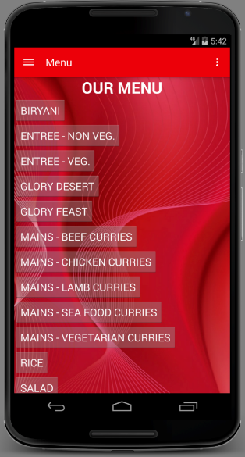 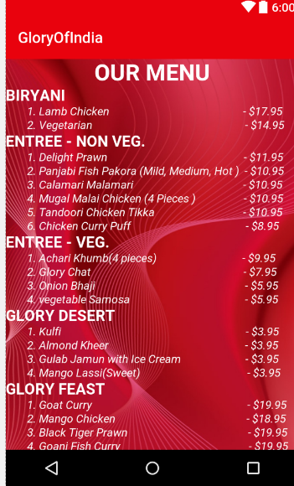

### **Reservations**

Description – This page has also been changed as per the requirement. The reservation option is also linked with the menu log.

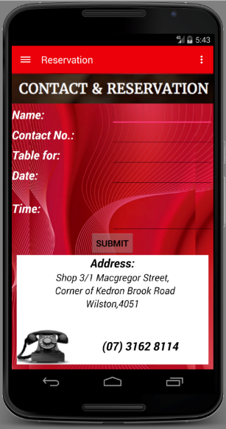 

### **Order now**

Description – we have connected the app with the menu log by having order now button with link on the home page. This button directs to the menu log, from where the customer can order.

## **USER Stories for final release**

### **Changing the menu further**

Priority – 20

Description – The client wants to have changes in the menu option. She wants the menu to be divided in the three parts by specifying in the horizontal panel on the menu screen, so that customer can easily navigate between the menu options.

Time estimation – 4 – 5 days

### Customer Feedback

Priority – 40

Description – The feedback or review option would be provided on the application for customers to review.

Time estimation – 5 days

### Registration/ Log in

Priority – 20

Description – The Registration page will be for customers to register online to avail any discounts or offers provided to members only.

Time estimation – 4 days

### Adding two more options in the navigation panel.

Description – Client wants to have the website option available on the app, so that customer can access the website from there without having searching problems.

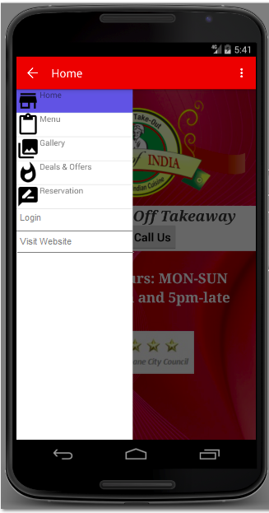

### Online search

Description – The last but not the least user story is having the search option in the application.

Time estimation – 4 days

### Final Bug fixes

Priority – 10

Description – Final bug fixes for any of the above attributes not functioning and to ensure the application is suitable for the final release.

Time estimation – 5 days

# Burn-down /Velocity chart

|  |  |  |  |  |
| --- | --- | --- | --- | --- |
| **Sn. No** | **User story** | **Priority** | **Estimated Time (In Days)** | **Actual Time** |
| 1 | Home | 10 | 10 | 12 |
| 2 | Order now | 20 | 5 | 7 |
| 3 | Menu | 30 | 8 | 7 |
| 4 | Gallery | 40 | 6 | 4 |
| 5 | Reservations  Total | 50 | 6  40 | 3  37 |

**Velocity** = actual delviery time/estimated time = 90 percent.

Calculation of the estimated time:

|  |  |
| --- | --- |
| Weeks | 6 |
| Members in the team | 4 |
| Working days per week | 2 |
| **Total estimated days of beta release** | **48 days** |

40 days for the user stories of beta release and 8 days for the bug fixing.

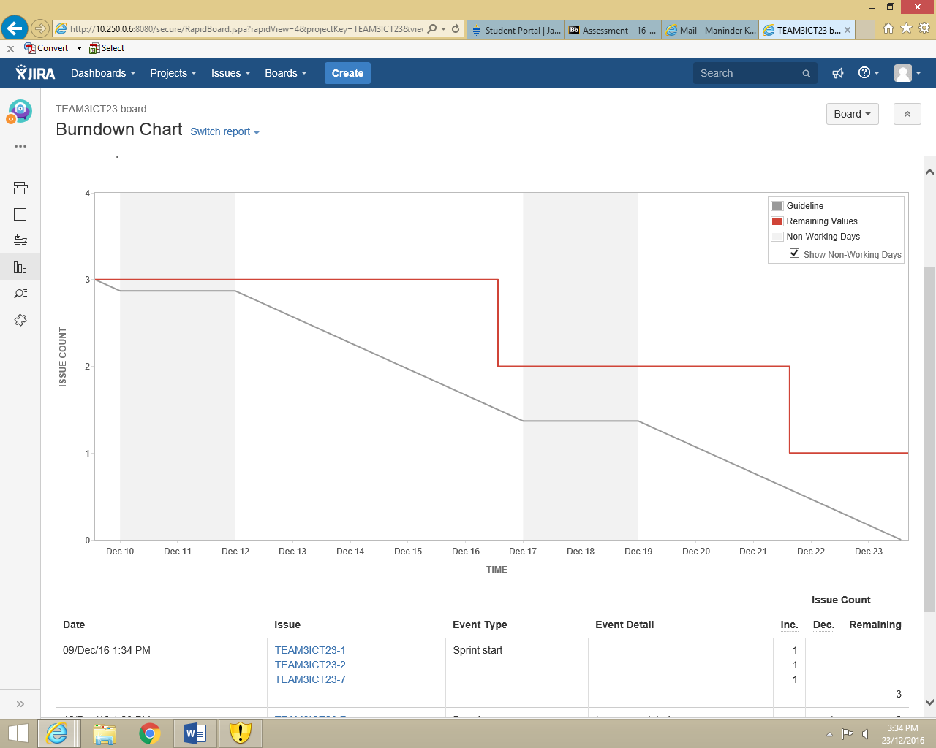

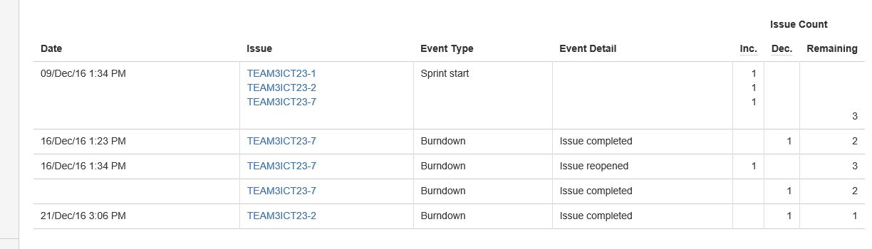

# Client signed acceptance of BETA release

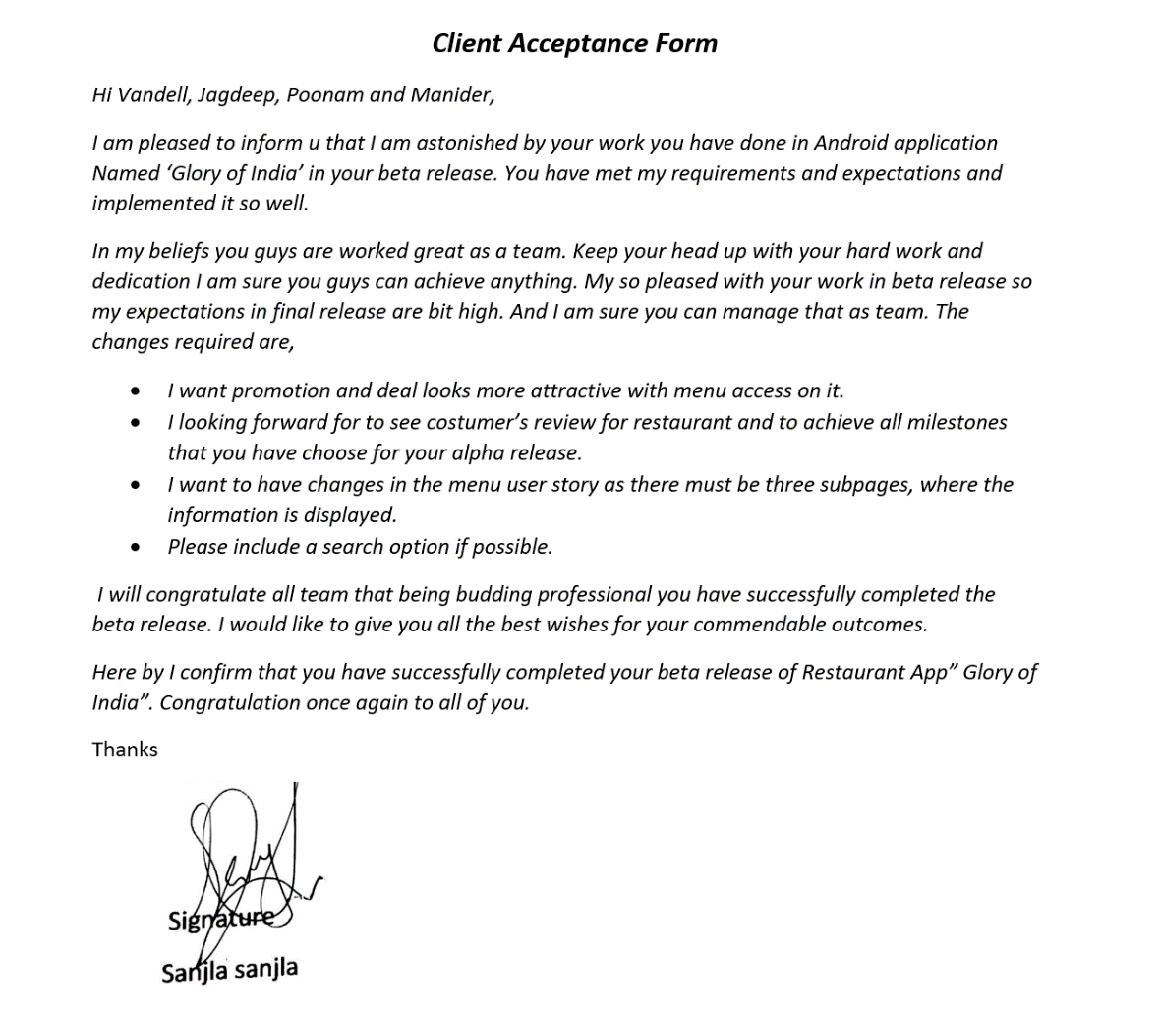

# Project development and release ICT infrastructure

## **Configuration management – Jira Software**

Jira software is a project management tool that allows to monitor the flow of the project so as to complete in the time. It is a very good service desk software to work in the teams. The works are assigned to the team members and they set the tasks to ‘in progress’ or ‘done’, which let the other team members about the progress of the project.

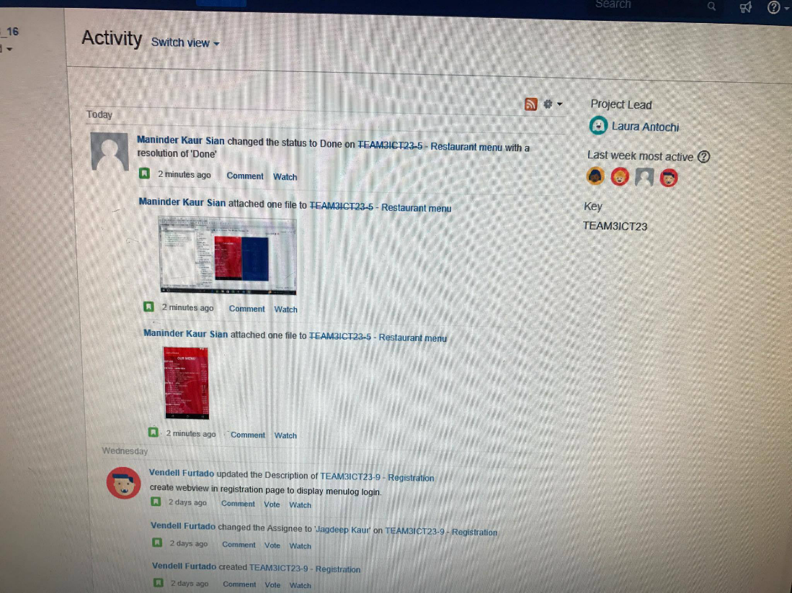

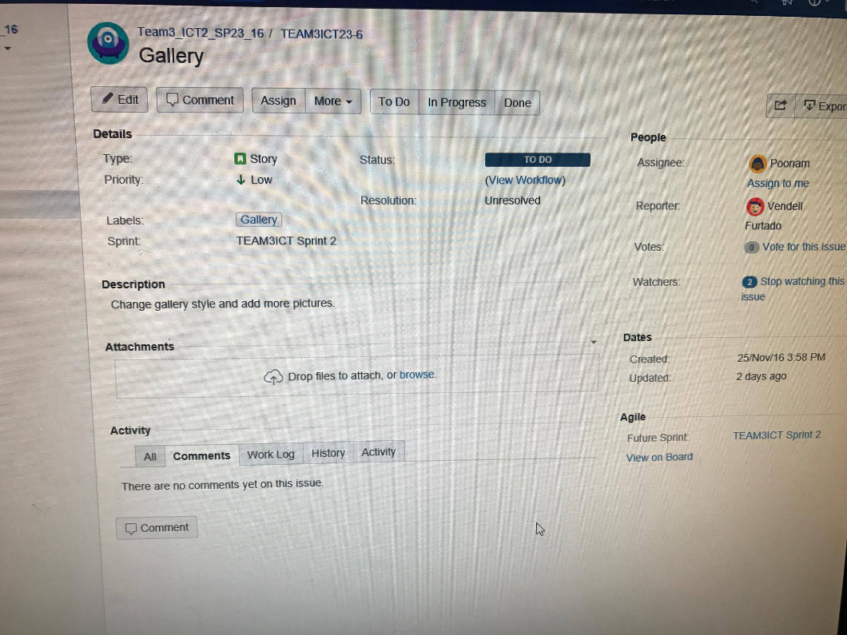

## **Programming languages**

* Java - it is general purpose high level language. The applications for android mobile phones can be designed by number of ways. Java is considered as best among all as per many developers. Designing apps from java has both the similarities and differences with other java designing applications (Java Basics, 2012).
* XML – it is the main theme of the android app. It is used to create the layouts for pages of the apps. On execution, the XML files will be read to have the result from the Java files.

## **Development tools – Android Studio**

Android Studio provides the fastest tools for building apps on every type of Android device (Android, 2016). World-class code editing, debugging, performance tooling, a flexible build system, and an instant build/deploy system all allow you to focus on building unique and high quality apps (Android, 2016).

#### Intelligent code editor

The code editor helps you write better code, work faster, and be more productive by offering advanced code completion, refactoring, and code analysis (Android, 2016). As you type, Android Studio provides suggestions in a dropdown list. Simply press Tab to insert the code (Android, 2016). This code editor is what we used as a base to edit and implement all our code on Android studio.

#### Fast and feature-rich emulator

The Android Emulator installs and starts your apps faster than a real device and allows you to prototype and test the app on all Android device configurations: phones, tablets, Android Wear, and Android TV devices (Android, 2016). You can also simulate a variety of hardware features such as GPS location, network latency, and multi-touch input (Android, 2016). The emulator was used to check the functionality and working of each and every fragment created in this application including various functions assigned to them.

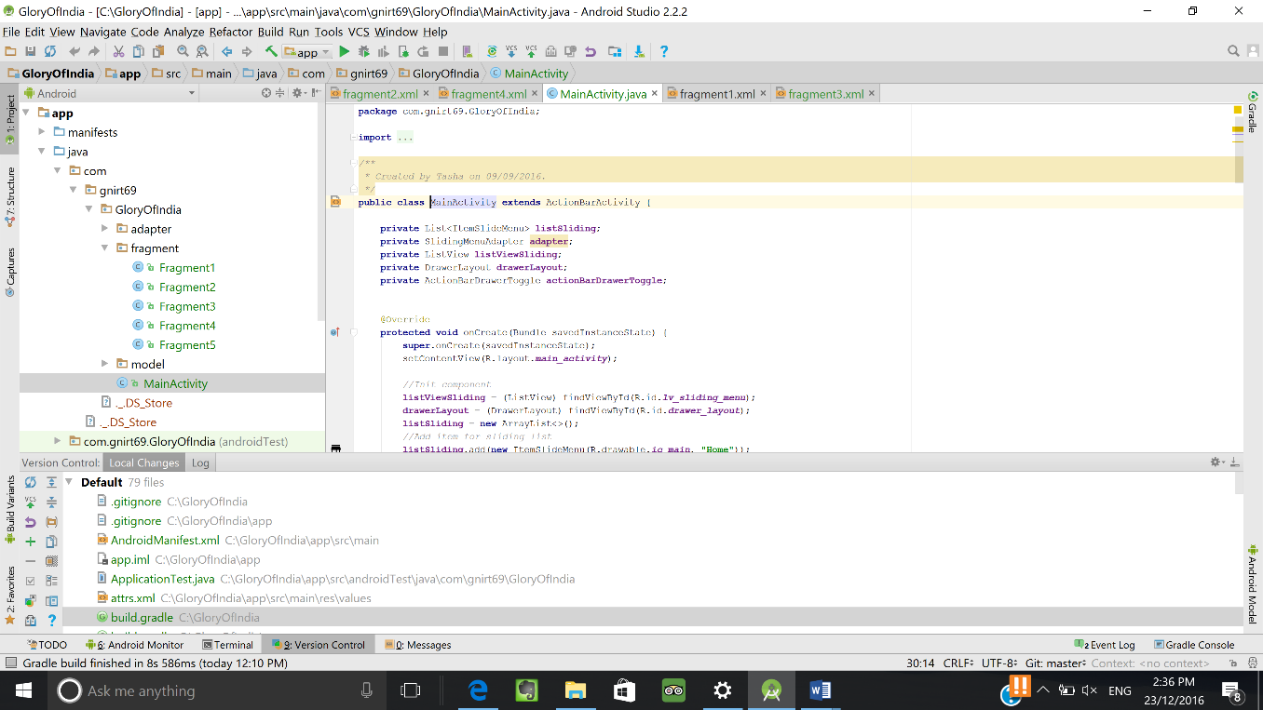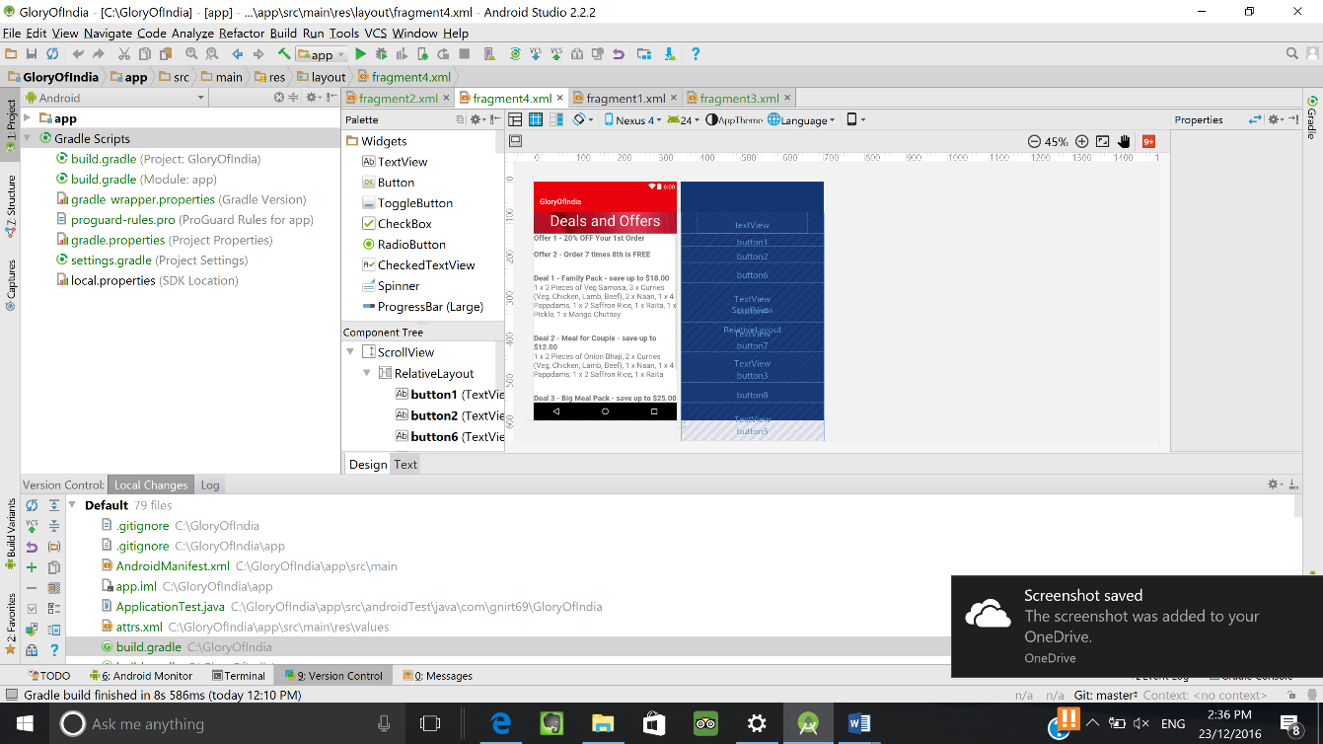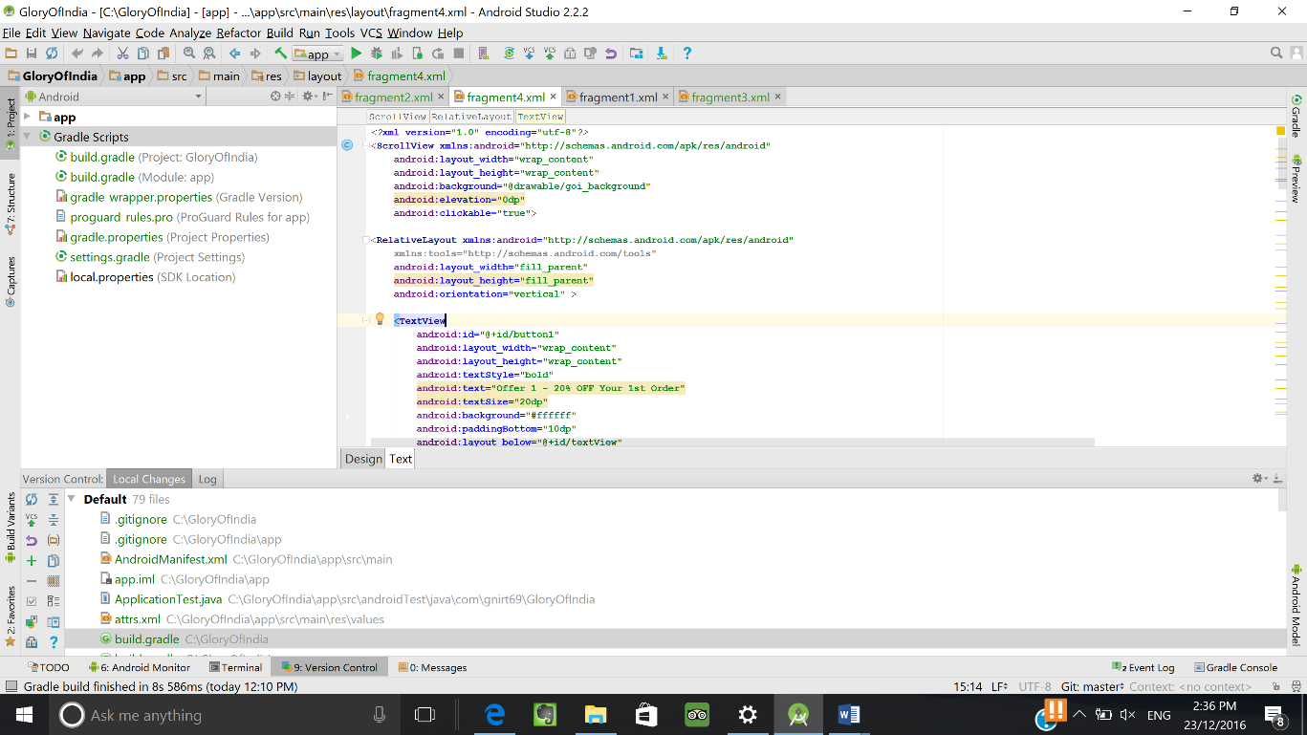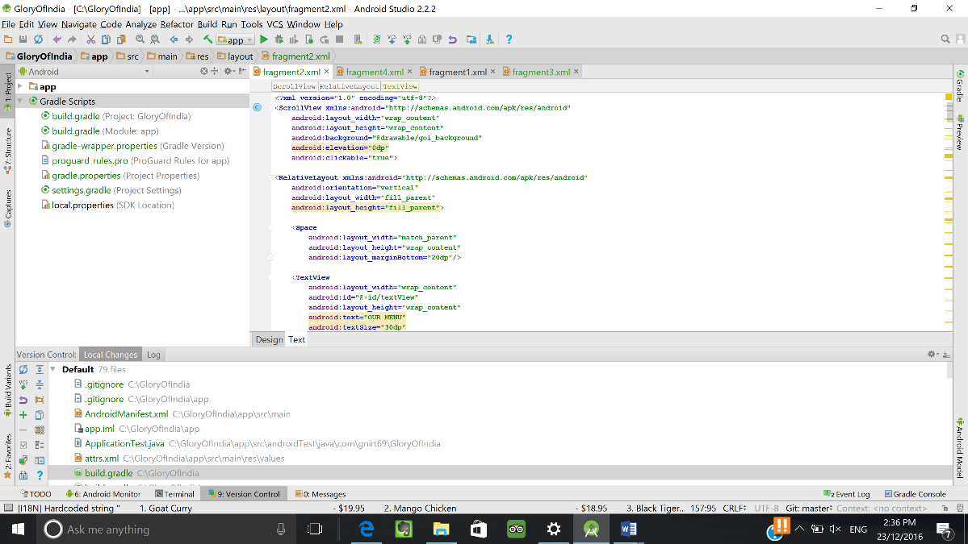

## **Testing Tools**

Application testing will be carried out by two procedures namely client testing and also by using Android studios in built emulator for testing purposes. The inbuilt emulator lets you test the application on your own Android phone by installing an apk or by starting the application on a virtual machine on the computer itself for testing and checking for any crashes or errors. Client testing will be done after initial bug fixes are made to the outcome achieved from testing it on the emulator or android phone. By using android studio you can test application on various UI tests (Android, 2016).

# Prototypes for the final release

|  |  |
| --- | --- |
| Customer login:  C:\Users\Tasha\Desktop\proto4.png | Feedback:  C:\Users\Tasha\Desktop\proto4.png |
| Menu:  C:\Users\Tasha\Desktop\proto4.png | Navigation panel  C:\Users\Tasha\Desktop\proto1.png |

# References

Android Studio. (2016). Everything you need to build on Android. Retrieved from <https://developer.android.com/studio/features.html>

Dabbish, L., Stuart, C., Tsay, J., & Herbsleb, J. (2012, February). Social coding in GitHub: transparency and collaboration in an open software repository. Proceedings of the ACM 2012 conference on Computer Supported Cooperative Work (pp. 1277-1286). ACM.

[Ben Jakuben](http://blog.teamtreehouse.com/author/benjakuben) (2012). Java Basics for Android Development – Part 1. Retrieved from <http://blog.teamtreehouse.com/java-basics-for-android-development-part-1>